Coordinate Geometry Proof

Christmas Break Project

DUE MONDAY JANAURY 3, 2018
*No late work will be accepted*

Ms. Samaroo: sheron.samaroo@equalitycharterschool.org
Ms. Landry: hannah.landry@equalitycharterschool.org
Website: www.ecsmathhs.weebly.com

Name: ___________________________

Period: ______________
Goal: Use properties of shapes and coordinate geometry to create an artistic masterpiece!

Instructions:
1) Choose at least 4 different geometric shapes from the following:

- Square
- Rectangle
- Rhombus
- Parallelogram
- Trapezoid
- Isosceles Trapezoid

2) What characteristics define your shapes? This length of sides, slope of sides, angles, etc. Be as specific as possible. For example, if you say a shape with 4 equal sides, you might mean a square. However, you could also be talking about a rhombus! If you aren’t sure, do some research!

Shape:  Characteristics/Properties: | Shape:  Characteristics/Properties:
Shape:  Characteristics/Properties: | Shape:  Characteristics/Properties:

3) Think about what it will take to prove that your shape is actually the shape you’re trying to make. For instance, for a square- you would need to show all 4 side lengths are equal and show that there are right angles (perpendicular lines).

Quadrilateral | What do we need to prove? | What formula will we use to prove that property?
4) You are creating the shapes yourself. Plot coordinates that make sense. Be colorful, clear, and organized. Avoid using shapes in standard orientation (i.e. squares with only vertical/horizontal sides, trapezoid with set of parallel sides horizontal, etc.)

5) For each shape, complete the following on your poster:

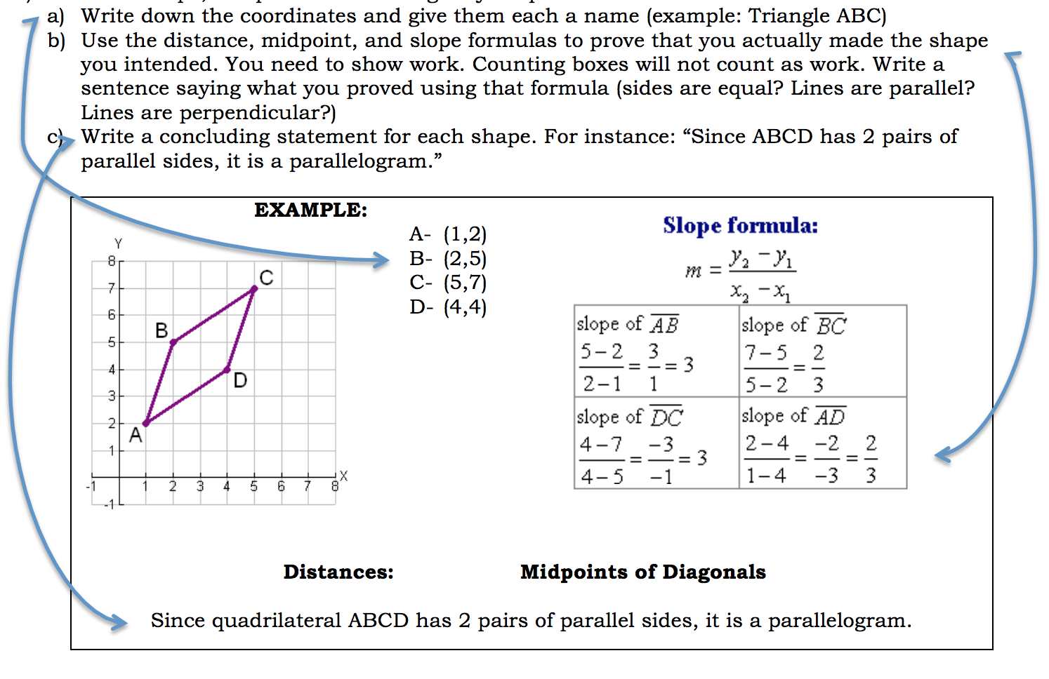

6) Create either a poster OR a booklet displaying all four of your shapes, calculations, and conclusions.

7) Use your leftover time to decorate and make professional!
__________________________________________________________________________________________

Grading Rubric

Element | Total Points | Points Earned
Characteristics | 8
Requirements for proof | 8
Accurate Graph | 12
Calculations (15 points per shape) | 60
Creativity & Effort & Neatness | 12
TOTAL | 100

