Name: ____________________________________ Date: _________________
4.18: Review Part 2 Geometry Period: ________
1.
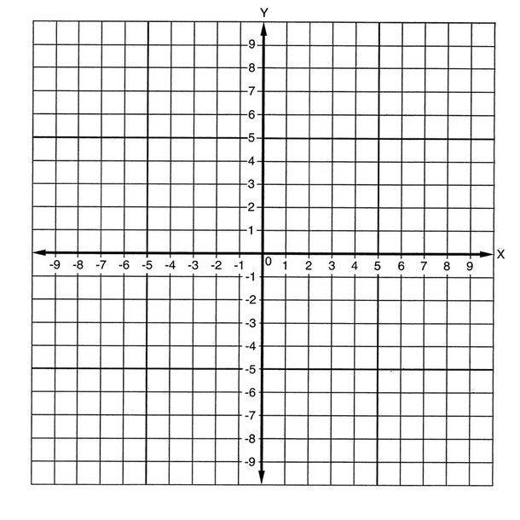

2.
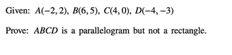

3.

4.

5.

